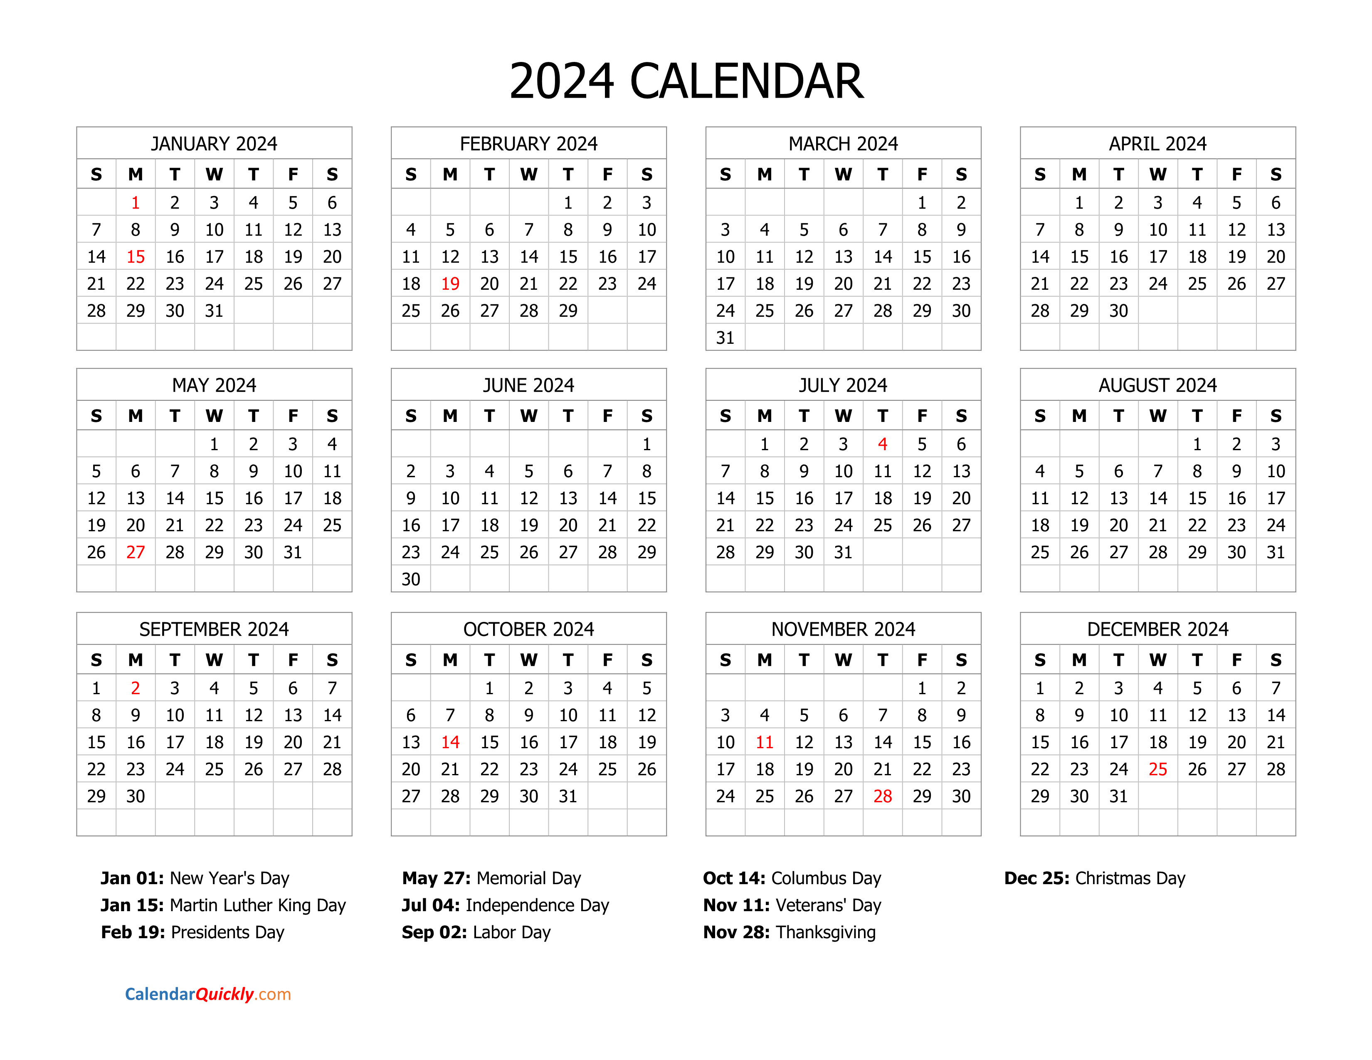

Thursday January 25th
Thursday February 29th
Thursday March 28th
Thursday April 25th
Thursday May 30th
Thursday June 27th
Thursday July 25th
Thursday August 29th
Thursday September 26th
^{Thursday October 31st}
** Due to Thanksgiving holiday and Christmas, we will not have a Stroke support group meeting on the last Thursday in November or December of 2024.

After a stroke, you may have questions and concerns about mobility, your daily activities, and other issues. The Tidelands Health Stroke Support Group is available in-person or virtually for stroke patients, their family members, and caregivers to help answer your questions.

When: Last Thursday of each month
Time: 1pm-2pm

Location: The YMCA in Pawleys Island
12965 Ocean Hwy Pawleys Island, SC

Or join us online:

Microsoft Teams meeting:
Meeting ID: 264 006 442 69
Passcode: MiJYAc
Join with a video conferencing device.
tidelandshealth@m.webex.com
Video Conference ID: 115 340 506 6

Stroke Support Group

