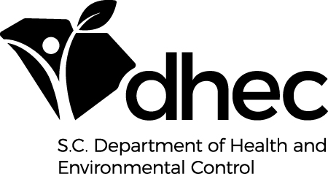

South Carolina Approved Proficiency Testing Providers

**All Proficiency Testing (PT) providers are not accredited for all types of PT samples, therefore view the laboratory’s scope of accreditation at their website. For the South Carolina PT requirements, please refer to our website at** [**www.scdhec.gov/labcert**](http://www.scdhec.gov/labcert) **or call our office for a copy of these requirements.**

**Absolute Standards, Inc.**

Phone: (800) 368-1131

Fax: (800) 410-2577

Website: [www.absolutestandards.com](http://www.absolutestandards.com)

**Advanced Analytical Solutions, LLC**

Phone: (800) 283-4844

Fax: (304) 485-6971

Website: [www.advancedqa.com](http://www.advancedqa.com)

**Environmental Resource Associates (ERA)**

Phone: (800) 372-0122

Fax: (303) 421-0159

Website: [www.eraqc.com](http://www.eraqc.com)

**NSI Solutions, Inc.**

Phone: (800) 234-7837

Fax: (919) 957-7562

Website: [www.nsi-es.com](http://www.nsi-es.com)

# Phenova, Inc.

Phone: (866) 942-2978

Fax: (866) 283-0269

Website: [www.phenova.com](http://www.phenova.com)

**MilliporeSigma Resource Technology Corporation (RTC)**

Phone: (800) 325-3010

Fax: (800) 325-5052

Website: [www.sigmaaldrich.com](http://www.sigmaaldrich.com)

**NYS DOH Environmental Lab Approval Program**

proficiency testing samples are also acceptable.